UNIT– V
SEARCHING AND SORTING TECHNIQUES

SEARCHING:
- Searching algorithms are designed to check whether an element is present or not from any data structure where it is stored.
- Given, group of elements and key element to be searched as input, any searching algorithm technique gives the position of the key element as the output.
- They are categorized into two types,
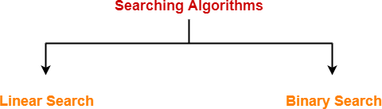
- Thearrayistraversed sequentially.
- Eg.LinearSearch
- Designedforsearching in sorted arrays.
- Eg.Binarysearch

Fig.3.1Categorizes of Searching Algorithm

LINEARSEARCH:
- Linear search is one of the sequential search algorithms, where the search starts from one end of the array and the target element is searched by comparing it with all the elements of array one by one in a sequence.

Working Steps:
  - Traverse the whole array using for loop
  - During every iteration, compare the target value with current value of the array element
If the value matches, return the current index of the array.
If the value doesn’t match, move onto the next array element.
  - If no match is found return-1.

Algorithm linear search(arr[],target)
- Declare arr[], target variable.
- For i=0ton-1
- If arr[i]==target
- Return i
- return-1
- end

Working of Algorithm:
Example array:
arr[0] arr[1] arr[2] arr[3] arr[4] arr[5]

55 | 44 | 11 | 22 | 99 | 77
target=99

Table3.1WorkingofLinearSearchAlgorithm

i | arr[i]==target? | Condition Satisfied?
0 | Checkif 55==99 | No
1 | Checkif 44==99 | No
2 | Checkif 11==99 | No
3 | Checkif 22==99 | No
4 | Checkif 99==99 | Yes

PROGRAM
#include <stdio.h>
int linearSearch(int arr[], int n, int key) {
for (int i = 0; i < n; i++) {
if (arr[i] == key)
return i;
}
return -1;
}
int main() {
int arr[100], n, key, result;
printf("Enter number of elements: ");
scanf("%d", &n);
printf("Enter %d elements:\n", n);
for (int i = 0; i < n; i++)
scanf("%d", &arr[i]);
printf("Enter element to search: ");
scanf("%d", &key);
result = linearSearch(arr, n, key);
if (result != -1)
printf("Element %d found at index %d.\n", key, result);
else
printf("Element %d not found in the array.\n", key);
return 0;
}

OUTPUT

Enter number of elements: 10
Enter 10 elements:
20 30 60 49 53 47 78 98 54 23
Enter element to search: 49
Element 49 found at index 3.

Advantage:
- Very simple and easy to implement.

Disadvantage:
- Consumes more time and space when compared with other searching algorithms.

Time Complexity:
- O(n)–n no.of comparisons is made to find the nth element.

BINARYSEARCH:
Binary Search is a searching algorithm that is used to search an element in a sorted array. It consumes less amount of time to search the element when compared with linear search.
Steps:
- Find the mid element of the array using mid formula.
  - If the target value is equal to middle element of the array return its index.
  - If not compare the mid element with target element.
    - If the target value is greater than the number in middle index, pick elements from the right-side part of the array and start from step 1
    - If the target value is less than the number in middle index then pick elements from the left side part of the array and start from step 1
- When the match is found, return the index of the corresponding element.
- If not, return-1.

Algorithm binarysearch(arr[],target)
- Declare variables low, high, target //low=startingindex, high=endingindex
- While low<high
- mid=(low+high)/2
- if arr[mid]<target
- low= mid+1
- elseif arr[mid]>target
- high=mid-1
- else
- return mid
- return -1 Working of Algorithm: Example array:
arr[0] arr[1] arr[2] arr[3] arr[4] arr[5] arr[6]

55 | 44 | 11 | 22 | 99 | 77 | 111
target=99

Table3.2Working of Binary Search Algorithm

While low<high | Mid | Compare arr[mid] and  target | low | high
0<6 | 0+6/2= 3 | 55<99 | 3 | 6
3<6 | 3+6/2= 4 | 77<99 | 5 | 6
5<6 | 5+6/2= 5 | 99==99 | 5 | 6

PROGRAM
#include <stdio.h>
int binarySearch(int arr[], int n, int key) {
int low = 0, high = n - 1;
while (low <= high) {
int mid = low + (high - low) / 2;
if (arr[mid] == key)
return mid;
else if (arr[mid] < key)
low = mid + 1;
else
high = mid - 1;
}
return -1;
}
int main() {
int arr[100], n, key, result;
printf("Enter number of elements (sorted array): ");
scanf("%d", &n);
printf("Enter %d elements in ascending order:\n", n);
for (int i = 0; i < n; i++)
scanf("%d", &arr[i]);
printf("Enter element to search: ");
scanf("%d", &key);
result = binarySearch(arr, n, key);
if (result != -1)
printf("Element %d found at index %d.\n", key, result);
else
printf("Element %d not found in the array.\n", key);
return 0;
}

OUTPUT
Enter number of elements (sorted array): 5
Enter 5 elements in ascending order:
10 20 30 40 50
Enter element to search: 40
Element 40 found at index 3.

Advantage:
- Very fast and efficient when compared with other searching algorithms.

Disadvantage:
- The array or list taken should already be sorted inorder to perform binary search.

Time Complexity:
- O(logn) – since, to find the nth element only less than or equal to n/2 comparisons are needed.
SORTING
- A sorting algorithm is used to re arrange a given array or list of elements according to a comparison operator on the elements.
- The two major categories of sorting algorithms are
  - Internal Sorting
    - All the data that has to be sorted can be adjusted at a time in the main memory
    - Eg. Bubblesort, HeapSort
  - External Sorting
    - Data that has to be sorted cannot be accommodated in the memory at the same time ans=d some has to be kept in auxiliary memory such as hard disk.
    - Eg. External MergeSort
- They are sub categorized into
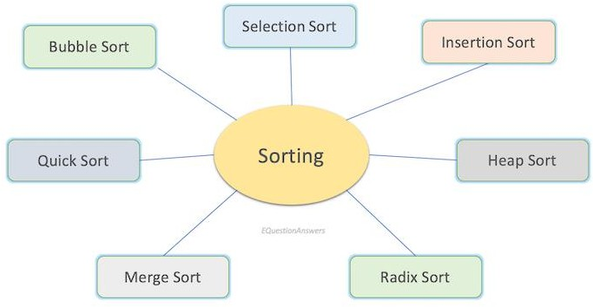
Fig.3.2CategorizesofSortingAlgorithm

BUBBLESORT:
- Bubble Sort is the simplest sorting algorithm that involves repeatedly swapping the adjacent elements if they are not in the required order (ascending/descending)
- By swapping the adjacent elements, this technique bubbles out the largest element to the end and hence it was named as bubble sort.
ALGORITHM
- Start
- Input the number of elements (n)
- Prompt the user to enter how many elements they want to sort.
- Declare an array of size n
- This uses a variable-length array (valid in C99 and later).
- Input n elements from the user into the array
- Display the original array
- Perform Bubble Sort
- For i from 0 to n - 2:
a. Set swapped = 0 (used to detect if any elements were swapped in this pass)
b. For j from 0 to n - i - 2:
i. If arr[j] > arr[j + 1]:
• Swap arr[j] and arr[j + 1]
• Set swapped = 1
c. If swapped == 0, then the array is already sorted → break the loop
- Display the sorted array
- End
Example array:
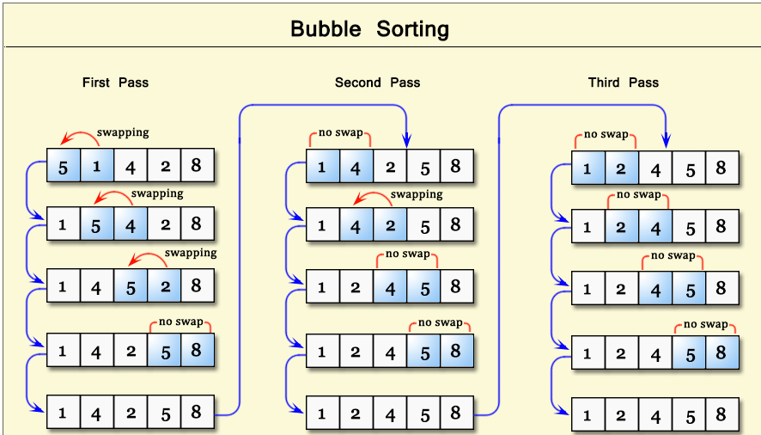

PROGRAM
#include <stdio.h>
void bubbleSort(int arr[], int n) {
for (int i = 0; i < n - 1; i++) {
int swapped = 0;
for (int j = 0; j < n - i - 1; j++) {
if (arr[j] > arr[j + 1]) {
int temp = arr[j];
arr[j] = arr[j + 1];
arr[j + 1] = temp;
swapped = 1;
}
}
if (!swapped) break;
}
}
void printArray(int arr[], int n) {
for (int i = 0; i < n; i++)
printf("%d ", arr[i]);
printf("\n");
}
int main() {
int n;
printf("Enter the number of elements: ");
scanf("%d", &n);
int arr[n]; // Variable-length array (C99 or later)
printf ("Enter %d elements:\n", n);
for (int i = 0; i < n; i++) {
scanf("%d", &arr[i]);
}
printf("Original array: ");
printArray(arr, n);
bubbleSort(arr, n);
printf("Sorted array: ");
printArray(arr, n);
return 0;
}
OUTPUT
Enter the number of elements: 5
Enter 5 elements:
64 25 12 22 11
Original array: 64 25 12 22 11
Sorted array: 11 12 22 25 64

Advantage: Simplest sorting algorithm and very easy to implement.

Disadvantage:Too slow and impractical when array is large.

Time Complexity:
- O(n2)– two for loops runs n*n times totally.

INSERTION SORT:
- Insertion sort is a simple algorithm that builds the final sorted array one by one.
- The lower part of the array is always sorted and any element to be inserted in this sorted sub array has to find its appropriate place to be inserted. And hence it’s named as insertion sort.

ALGORITHM
1. Start
2. Declare variables
- i, j, k: loop counters
- n: number of elements
- temp: temporary variable for insertion
- a[20]: array to store elements (max 20)
- p: pass counter, initially 0
3. Input the number of elements
- Prompt: "Enter total elements: "
- Read n
4. Input n elements into array a
- Prompt: "Enter array elements: "
- For i = 0 to n-1:
  - Read a[i]
5. Perform Insertion Sort
For i = 1 to n-1:
a. Set temp = a[i]
b. Set j = i - 1
c. While j >= 0 and temp < a[j]:
i. Move a[j] to position j + 1
ii. Decrement j
d. Insert temp at position j + 1
e. Increment pass counter p
f. Print the array after each pass:
- "After Pass %d: " followed by the current array contents
6. After sorting, print the sorted list
- "Sorted List : " followed by the array
7. End

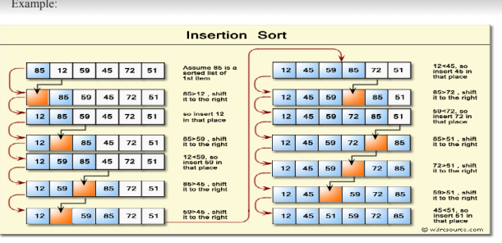

PROGRAM

#include <stdio.h>
int main()
{
int i, j, k, n, temp, a[20], p=0;
printf("Enter total elements: ");
scanf("%d",&n);
printf("Enter array elements: ");
for(i=0; i<n; i++)
scanf("%d", &a[i]);
for(i=1; i<n; i++)
{
temp = a[i];
j = i - 1;
while((temp<a[j]) && (j>=0))
{
a[j+1] = a[j];
j = j - 1;
}
a[j+1] = temp;
p++;
printf("\n After Pass %d: ", p);
for(k=0; k<n; k++)
printf(" %d", a[k]);

printf("\n Sorted List : ");
for(i=0; i<n; i++){
printf(" %d", a[i]);
}
printf("\n");
return 0;
}

OUTPUT

Enter total elements: 6
Enter array elements: 23 1 43 10 57 2
After Pass 1: 1 23 43 10 57 2
After Pass 2: 1 23 43 10 57 2
After Pass 3: 1 10 23 43 57 2
After Pass 4: 1 10 23 43 57 2
After Pass 5: 1 2 10 23 43 57
Sorted List : 1 2 10 23 43 57

Advantage: Simple implementation and efficient for small datasets.

Disadvantage: Much less efficient for large datasets.

Complexity: O(n2)–two loops run n*n times for n variables.

Divide and Conquer Strategy:
- Divide and Conquer is an algorithm design strategy that works by recursively breaking down the given problem into two or more sub problems until it becomes to be solved directly.
- Eg.QuickSort, Merge Sort.

QUICKSORT:
- Quick Sort is an efficient sorting algorithm that uses divide and conquer technique to sort the given set of elements in an array.
- It takes first/last element as pivot element and places the pivot element at its right place by comparing it with other elements.
- It recursively divides the array after pivot element reaches its appropriate place and the procedure is called again recursively for the remaining part of the array.

AlgorithmPartition(arr[],start,end)
- pivot=end
- pindex=start
- fori=start ton-2
- ifarr[i] <arr[pivot]
- swaparr[i],arr[pindex]
- pindex=pindex+1
- swap(arr[pivot],arr[pindex])
- returnpindex

Algorithm QuickSort(arr[],n,start,end)
- ifstart<end
- pindex=partition(arr[],start,end)
- QuickSort(arr[],start,pindex-1)
- QuickSort(arr[],pindex+1, end)

Working of Algorithm:Example array:
arr[0] arr[1] arr[2] arr[3] arr[4] arr[5]

Before Sorting
55 | 45 | 5 | 75 | 15 | 25

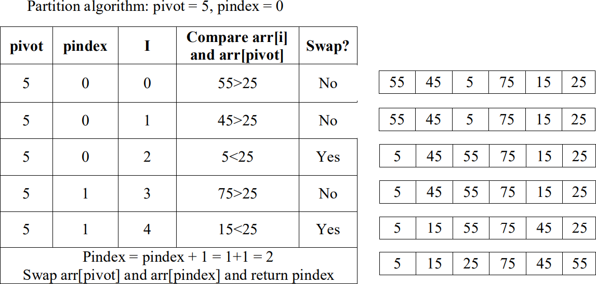

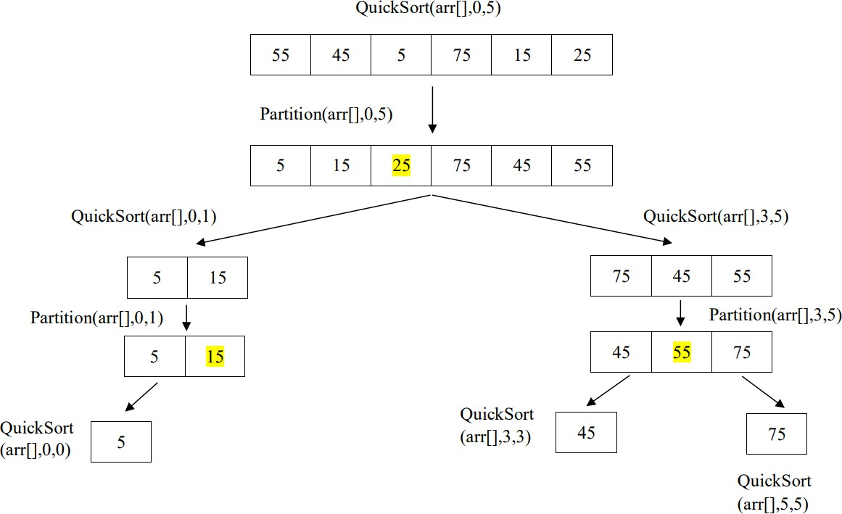
Fig.3.4 WorkingofQuick Sort Algorithm

AfterSorting
5 | 15 | 25 | 45 | 55 | 75

  - The above tree explains the function call order for the considered example. The shaded number denotes the value of pindex after calling the partition sub routine.

Advantage:
  - It is the most efficient sorting algorithm, when implemented well it can be three times faster than merge sort.

Disadvantage:
  - In worstcase,the number of comparisons will be more.

Complexity:
  - O(nlogn):withncomparisonsinpartitionalgorithmandusingdivideandconquer strategy for recursive quicksort subroutine, the whole complexity sums to nlogn.

PROGRAM
#include <stdio.h>
void swap(int arr[], int i, int j) {
int temp = arr[i];
arr[i] = arr[j];
arr[j] = temp;
}
int partition(int arr[], int low, int high) {
int pivot = arr[high];
int i = low - 1;
for (int j = low; j < high; j++) {
if (arr[j] < pivot) {
i++;
swap(arr, i, j);
}
}
swap(arr, i + 1, high);
return i + 1;
}
void quickSort(int arr[], int low, int high) {
if (low < high) {
int pi = partition(arr, low, high);

quickSort(arr, low, pi - 1);
quickSort(arr, pi + 1, high);
}
}
void printArray(int arr[], int n) {
for (int i = 0; i < n; i++)
printf("%d ", arr[i]);
printf("\n");
}
int main() {
int n;
printf("Enter number of elements: ");
scanf("%d", &n);
int arr[n];
printf("Enter %d elements:\n", n);
for (int i = 0; i < n; i++)
scanf("%d", &arr[i]);
printf("Original array: ");
printArray(arr, n);
quickSort(arr, 0, n - 1);
printf("Sorted array: ");
printArray(arr, n);
return 0;
}

OUTPUT
Enter number of elements: 5
Enter 5 elements:
64 25 12 22 11
Original array: 64 25 12 22 11
Sorted array: 11 12 22 25 64

MERGESORT:
  - MergeSort is a divide and conquer algorithm that recursively divides the array into sub arrays, sort those separately and merges together to get the final sorted array.
  - It uses two functions, one for dividing and the other for sorting and merging.

Algorithm MergeSort(arr[],i,j,mid)
- ifi<j
- mid=i+j/2
- MergeSort(arr[],i,mid)
- MergeSort(arr[],mid+1,j)
- Merge(arr[],i,mid,mid+1,j)

AlgorithmMerge(arr[],i1,i2,j1,j2)
- declaretemp[50],i,j,k
- i=i1,j=j2,k=0
- whilei<=j1andj<=j2
- ifarr[i]<arr[j]
- temp[k]= arr[i]
- k++,i++
- else
- temp[k]= arr[j]
- k++,j++
- whilei<=j1
- temp[k]= arr[i]
- k++,i++
- whilej<=j2
- temp[k]= arr[j]
- k++,j++
- move elements from temporary array to arr[i]
AlgorithmWorking:
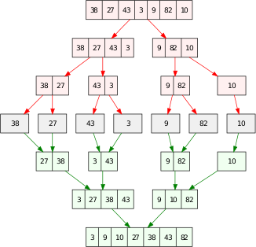
Fig.3.5Working of MergeSort Algorithm
PROGRAM
#include <stdio.h>
void merge(int [],int,int,int );
void part(int [],int,int );
int size;
int main()
{
int i, a[30];
printf("Enter total no. of elements : ");
scanf("%d", &size);
printf("Enter array elements : ");
for(i=0; i<size; i++)
scanf("%d", &a[i]);
part(arr, 0, size-1);
printf("\n Merge sorted list : ");
for(i=0; i<size; i++)
printf("%d ",a[i]);
}

void part(int a[], int min, int max)
{
int mid;
if(min < max)
{
mid = (min + max) / 2;
part(a, min, mid);
part(a, mid+1, max);
merge(a, min, mid, max);
}
if (max-min == (size/2)-1)
{
printf("\n Half sorted list : ");
for(int i=min; i<=max; i++)
printf("%d ", a[i]);
}
}
void merge(int a[],int min,int mid,int max)
{
int tmp[30];
int i, j, k, m;
j = min;
m = mid + 1;
for(i=min; j<=mid && m<=max; i++)
{
if(a[j] <= a[m])
{
tmp[i] = a[j];
j++;
}
else
{
tmp[i] = a[m];
m++;
}
}
if(j > mid)
{
for(k=m; k<=max; k++)
{
tmp[i] = a[k];
i++;
}
}
else
{
for(k=j; k<=mid; k++)
{
tmp[i] = a[k];
i++;
}
}
for(k=min; k<=max; k++)
a[k] = tmp[k];
}

OUTPUT
Enter total no. of elements : 10
Enter array elements : 99 100 45 1 34 68 29 3 688 4
Half sorted list : 1 34 45 99 100
Half sorted list : 3 4 29 68 688
Merge sorted list : 1 3 4 29 34 45 68 99 100 688

Advantage:
  - Efficient general-purpose algorithm.

Disadvantage:
  - In some cases, its performance is less when compared to quicksort.

Complexity:
  - O(nlogn)-withncomparisonsinmergealgorithmandusingdivideandconquer strategy for recursive mergesort subroutine, the whole complexity sums to nlogn.

SELECTIONSORT:
- Selection sort is a simple sorting algorithm. This sorting algorithm is an in-place comparison-based algorithm in which the list is divided into two parts, the sorted part at the left end and the unsorted part at the right end. Initially, the sorted part is empty and the unsorted part is the entire list.
- The smallest element is selected from the unsorted array and swapped with the leftmost element, and that element becomes a part of the sorted array. This process continues moving unsorted array boundary by one element to the right.
- This algorithm is not suitable for large data sets as its average and worst-case complexities are of Ο(n2), where n is the number of items.
ALGORITHM
1. Start
2. Declare variables
- n: number of elements
- i, j, k: loop counters
- t: temporary variable for swapping
- min: index of the minimum value
- a[20]: array to hold up to 20 elements
- p: pass counter (initially 0)
3. Input the number of elements
- Display: "Enter total elements: "
- Read n
4. Input the array elements
- Display: "Enter n elements:"
- For i = 0 to n-1:
  - Read a[i]
5. Perform Selection Sort
For i = 0 to n - 2:
a. Set min = i (assume the current element is the smallest)
b. For j = i + 1 to n - 1:
- If a[j] < a[min], set min = j (update the index of the smallest element)
c. Swap a[i] and a[min]
d. Increment pass counter p
e. Print the array after each pass:
- "After Pass p : " followed by the array
6. Print the final sorted list
- Display: "Sorted List: " followed by sorted elements
7. End.

How Selection Sort Works?
- Consider the following depicted array as an example.
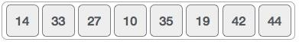
- For the first position in the sorted list, the whole list is scanned sequentially. The first position where 14 is stored presently, we search the whole list and find that 10 is the lowest value.
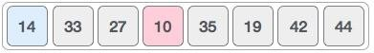
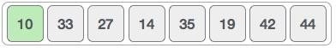
- So we replace 14with10. After one iteration10, which happens to be the minimum value in the list, appears in the first position of the sorted list.
- For the second position, where 33 is residing, we start scanning the rest of the list in a linear manner.
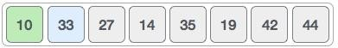
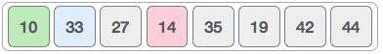
- We find that 14 is the second lowest value in the list and it should appear at the second place. We swap these values.
- After two iterations, two least values are positioned at the beginning in a sorted manner.
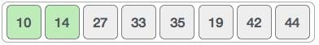
- The same process is applied to the rest of the items in the array. Following is a pictorial depiction of the entire sorting process –
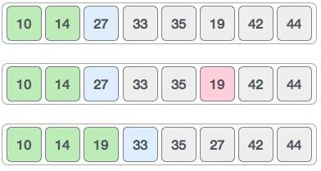
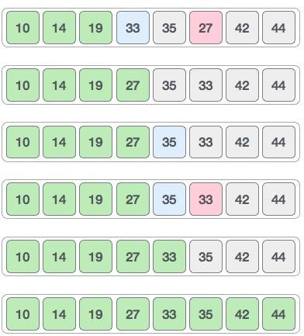

PROGRAM
#include <stdio.h>
int main()
{
int n, i, j, k, t, min, a[20], p=0;
printf("Enter total elements: ");
scanf("%d",&n);
printf("Enter %d elements : ", n);
for(i=0; i<n; i++)
scanf("%d", &a[i]);
for(i=0; i<n-1; i++)
{
min = i;
for(j=i+1; j<n; j++)
{
if(a[j] < a[min])
min = j;
}
t = a[i];
a[i] = a[min];
a[min] = t;
p++;
printf("\n After Pass %d : ", p);
for(k=0; k<n; k++)
printf("%d ", a[k]);
}
printf("\n Sorted List : ");
for(i=0; i<n; i++)
printf("%d ", a[i]);
}

OUTPUT :
Enter total elements: 8
Enter 8 elements : 100 4 56 3 34 89 43 88
After Pass 1 : 3 4 56 100 34 89 43 88
After Pass 2 : 3 4 56 100 34 89 43 88
After Pass 3 : 3 4 34 100 56 89 43 88
After Pass 4 : 3 4 34 43 56 89 100 88
After Pass 5 : 3 4 34 43 56 89 100 88
After Pass 6 : 3 4 34 43 56 88 100 89
After Pass 7 : 3 4 34 43 56 88 89 100
Sorted List : 3 4 34 43 56 88 89 100

ANALYSIS OF SORTING TECHNIQUES:
- All the Sorting algorithms are used for single objective, to sort the elements in any sequential order, but still there are so many different algorithms available for sorting.
- This is because of the fact that each sorting algorithm has its own advantage and disadvantages, to overcome the disadvantage of the previous algorithm technique new technique is invented each time.
- To measure the efficiency of the sorting algorithms, time and space complexity is computed for each one separately.
- Time Complexity: total amount of time consumed to run the algorithm.
- Space Complexity: total amount of space computed by the algorithm.
- Since the space consumed might vary from machine to machine due to different hardwares used, time complexity is usually preferred to check the efficiency of the algorithm.
- Thetimecomplexitycanbefoundforbestcase(inputmightbesortedalready),average case (input will have randomly distributed elements) and worst case (input will have elements in reverse order)
Table3.6AnalysisofSortingAlgorithms

SortingAlgorithm | BestCase | AverageCase | WorstCase
BubbleSort | O(n) | O(n2) | O(n2)
InsertionSort | O(n) | O(n2) | O(n2)
QuickSort | O(nlogn) | O(nlogn) | O(n2)
MergeSort | O(nlogn) | O(nlogn) | O(nlogn)
Selection Sort | O(n) | O(n2) | O(n2)

HASHING

Hashing refers to the process of generating a small sized output (that can be used as index in a table) from an input of typically large and variable size. Hashing uses mathematical formulas known as hash functions to do the transformation. This technique determines an index or location for the storage of an item in a data structure called Hash Table.

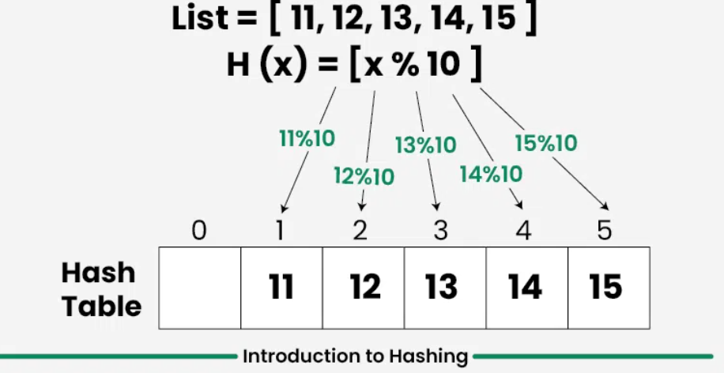

Hash Table Data Structure Overview
- It is one of the most widely used data structure after arrays.
- It mainly supports search, insert and delete in O(1) time on average which is more efficient than other popular data structures like arrays, Linked List and Self Balancing BST.
- We use hashing for dictionaries, frequency counting, maintaining data for quick access by key, etc.
- Real World Applications include Database Indexing, Cryptography, Caches, Symbol Table and Dictionaries.
- There are mainly two forms of hash typically implemented in programming languages.
Hash Set : Collection of unique keys
- Hash Map : Collection of key value pairs with keys being unique

Components of Hashing
- Key: A Key can be anything string or integer which is fed as input in the hash function the technique that determines an index or location for storage of an item in a data structure.
- Hash Function: Receives the input key and returns the index of an element in an array called a hash table. The index is known as the hash index .
- Hash Table: Hash table is typically an array of lists. It stores values corresponding to the keys. Hash stores the data in an associative manner in an array where each data value has its own unique index.
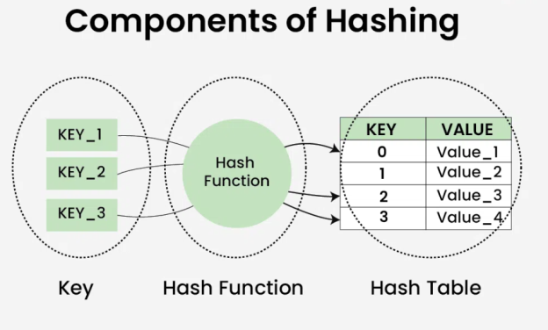

How does Hashing work?
Suppose we have a set of strings {“ab”, “cd”, “efg”} and we would like to store it in a table.

- Step 1: We know that hash functions (which is some mathematical formula) are used to calculate the hash value which acts as the index of the data structure where the value will be stored.
- Step 2: So, let's assign
  - “a” = 1,
  - “b”=2, .. etc, to all alphabetical characters.
- Step 3: Therefore, the numerical value by summation of all characters of the string:
- “ab” = 1 + 2 = 3,
- “cd” = 3 + 4 = 7 ,
- “efg” = 5 + 6 + 7 = 18
- Step 4: Now, assume that we have a table of size 7 to store these strings. The hash function that is used here is the sum of the characters in key mod Table size . We can compute the location of the string in the array by taking the sum(string) mod 7 .
- Step 5: So we will then store
  - “ab” in 3 mod 7 = 3,
  - “cd” in 7 mod 7 = 0, and
  - “efg” in 18 mod 7 = 4.

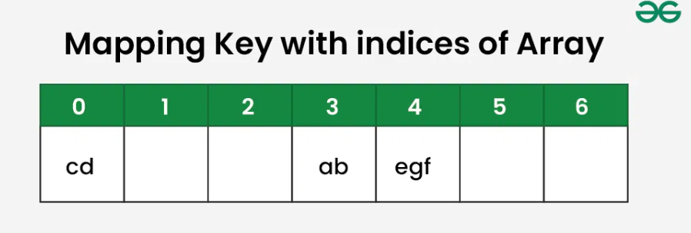

What is a Hash function?
A hash function creates a mapping from an input key to an index in hash table, this is done through the use of mathematical formulas known as hash functions. For example: Consider phone numbers as keys and a hash table of size 100. A simple example hash function can be to consider the last two digits of phone numbers so that we have valid array indexes as output.

A good hash function should have the following properties:
- Efficient
- Should uniformly distribute the keys to each index of hash table.
- Should minimize collisions (This and the below are mainly derived from the above 2nd point)
- Should have a low load factor (number of items in the table divided by the size of the table).

What is Collision in Hashing?
When two or more keys have the same hash value, a collision happens. If we consider the above example, the hash function we used is the sum of the letters, but if we examined the hash function closely then the problem can be easily visualised that for different strings same hash value is being generated by the hash function.

For example: {“ab”, “ba”} both have the same hash value, and string {“cd”,”be”} also generate the same hash value, etc. This is known as collision and it creates problem in searching, insertion, deletion, and updating of value.

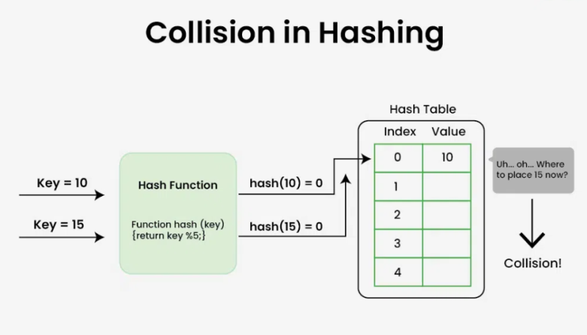

Collision Resolution Techniques

There are mainly two methods to handle collision:
- Separate Chaining
- Open Addressing

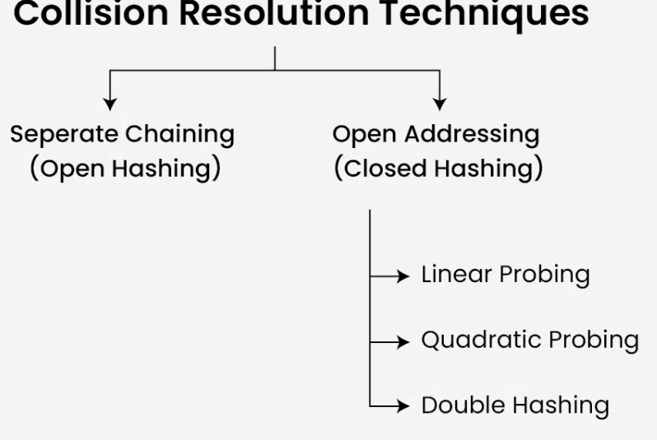

1) Separate Chaining
The idea behind Separate Chaining is to make each cell of the hash table point to a linked list of records that have the same hash function value. Chaining is simple but requires additional memory outside the table.

Example: We have given a hash function and we have to insert some elements in the hash table using a separate chaining method for collision resolution technique.

Hash function = key % 5,
Elements = 12, 15, 22, 25 and 37.
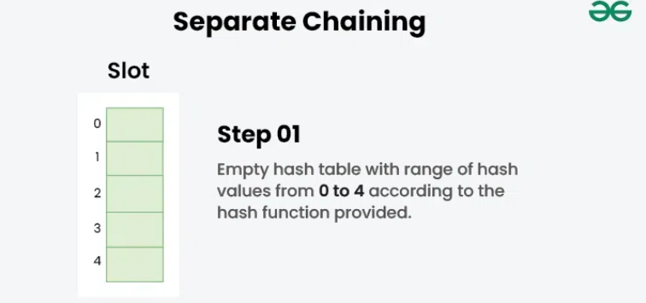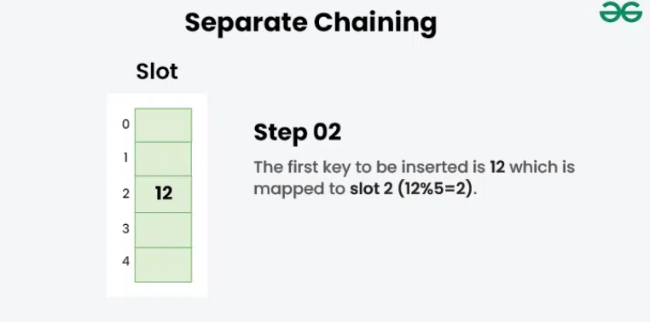

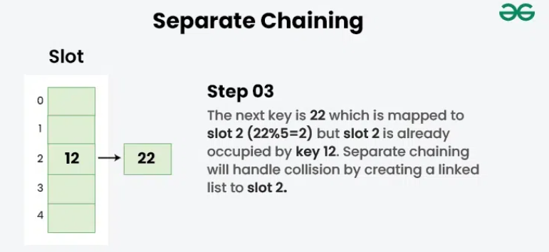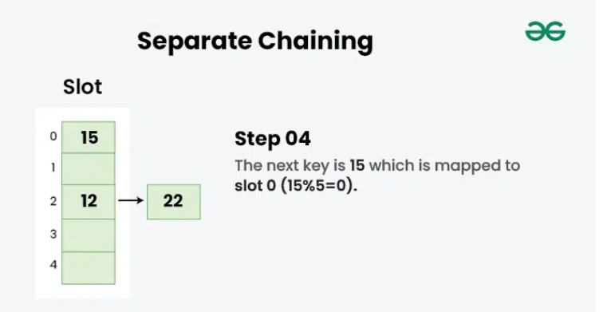

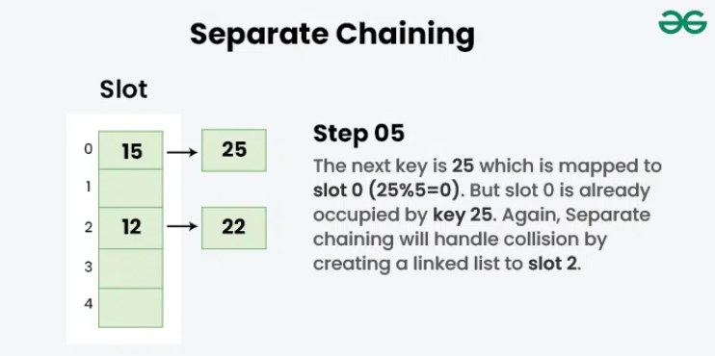

2) Open Addressing
In open addressing, all elements are stored in the hash table itself. Each table entry contains either a record or NIL. When searching for an element, we examine the table slots one by one until the desired element is found or it is clear that the element is not in the table.

2.a) Linear Probing
In linear probing, the hash table is searched sequentially that starts from the original location of the hash. If in case the location that we get is already occupied, then we check for the next location.

Algorithm:
- Calculate the hash key. i.e. key = data % size
- Check, if hashTable[key] is empty
  - store the value directly by hashTable[key] = data
- If the hash index already has some value then
  - check for next index using key = (key+1) % size
- Check, if the next index is available hashTable[key] then store the value. Otherwise try for next index.
- Do the above process till we find the space.

Example: Let us consider a simple hash function as “key mod 5” and a sequence of keys that are to be inserted are 50, 70, 76, 85, 93.

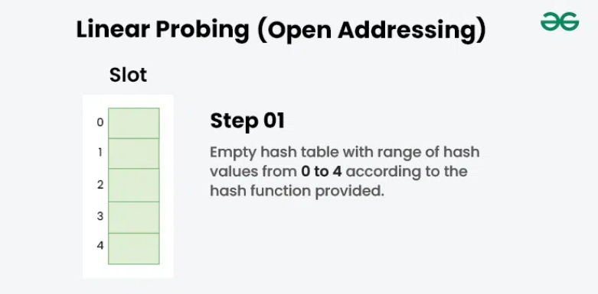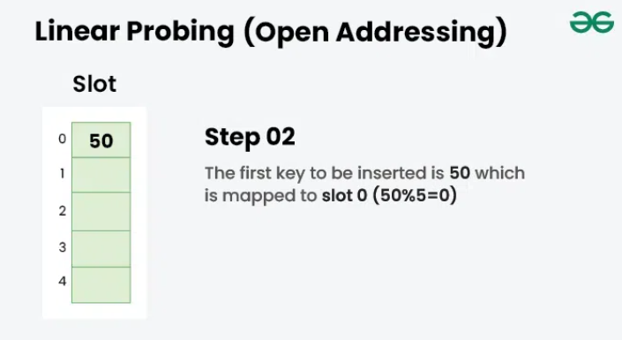

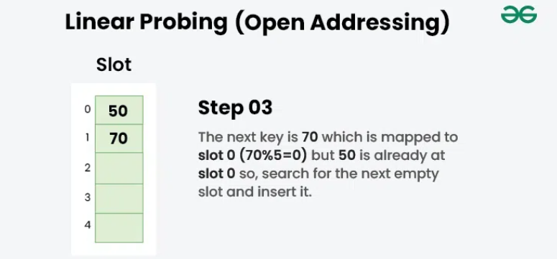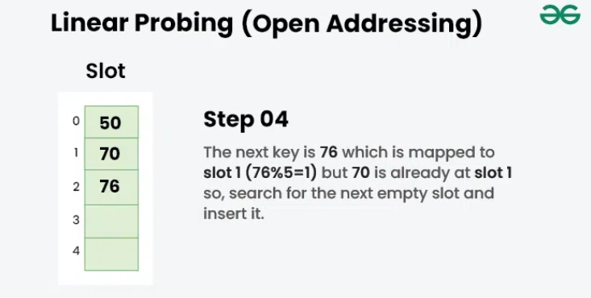

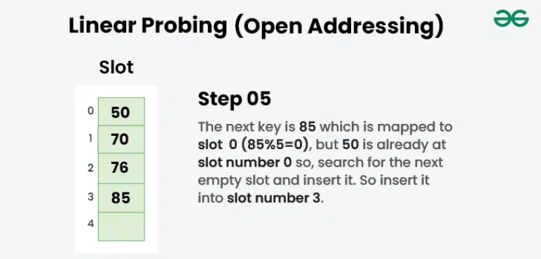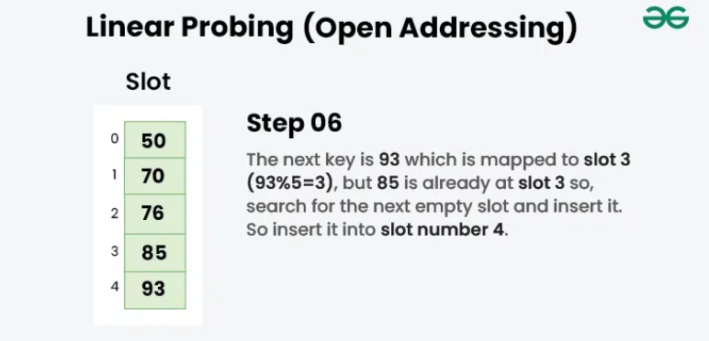

2.b) Quadratic Probing
Quadratic probing is an open addressing scheme in computer programming for resolving hash collisions in hash tables. Quadratic probing operates by taking the original hash index and adding successive values of an arbitrary quadratic polynomial until an open slot is found.

An example sequence using quadratic probing is:
H + 1 2 , H + 2 2 , H + 3 2 , H + 4 2 ...................... H + k 2
This method is also known as the mid-square method because in this method we look for i2-th probe (slot) in i-th iteration and the value of i = 0, 1, . . . n – 1. We always start from the original hash location. If only the location is occupied then we check the other slots.

Let hash(x) be the slot index computed using the hash function and n be the size of the hash table.

If the slot hash(x) % n is full, then we try (hash(x) + 1 2 ) % n.
If (hash(x) + 1 2 ) % n is also full, then we try (hash(x) + 2 2 ) % n.
If (hash(x) + 2 2 ) % n is also full, then we try (hash(x) + 3 2 ) % n.
This process will be repeated for all the values of i until an empty slot is found

Example: Let us consider table Size = 7, hash function as Hash(x) = x % 7 and collision resolution strategy to be f(i) = i 2 . Insert = 22, 30, and 50

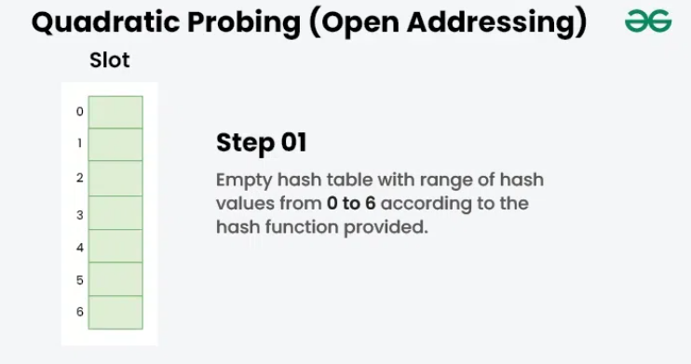
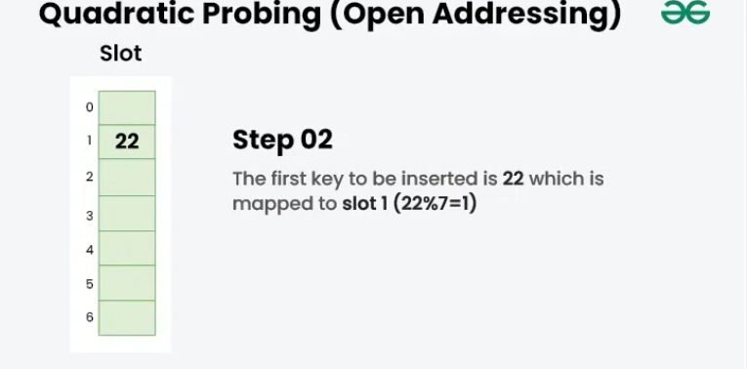
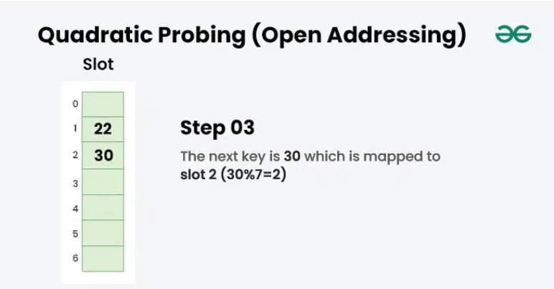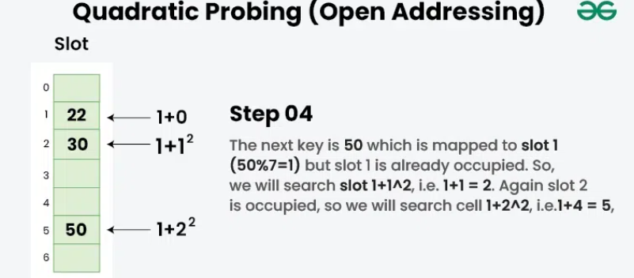

2.c) Double Hashing
Double hashing is a collision resolving technique in Open Addressed Hash tables. Double hashing make use of two hash function,

- The first hash function is h1(k) which takes the key and gives out a location on the hash table. But if the new location is not occupied or empty then we can easily place our key.
- But in case the location is occupied (collision) we will use secondary hash-function h2(k) in combination with the first hash-function h1(k) to find the new location on the hash table.
This combination of hash functions is of the form
h(k, i) = (h1(k) + i * h2(k)) % n
where
- i is a non-negative integer that indicates a collision number,
- k = element/key which is being hashed
- n = hash table size.
Complexity of the Double hashing algorithm:
Time complexity: O(n)

Example: Insert the keys 27, 43, 692, 72 into the Hash Table of size 7. where first hash-function is h1​(k) = k mod 7 and second hash-function is h2(k) = 1 + (k mod 5) 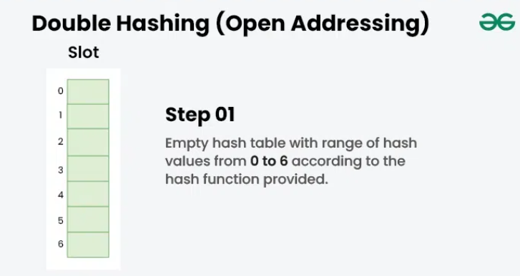 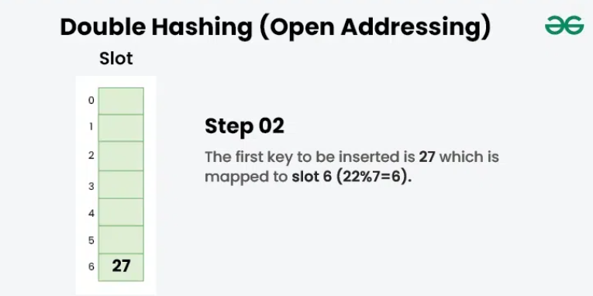

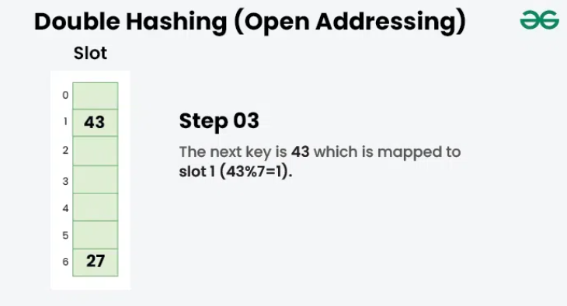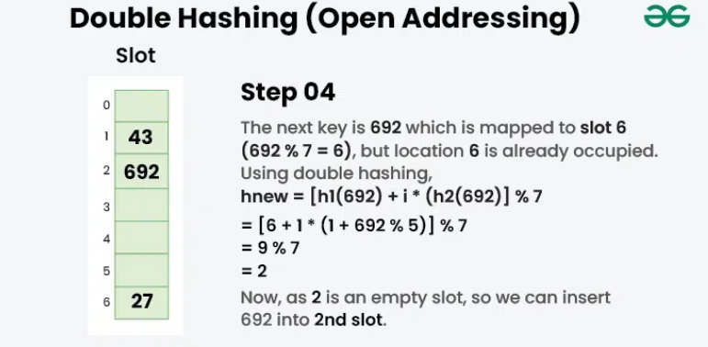

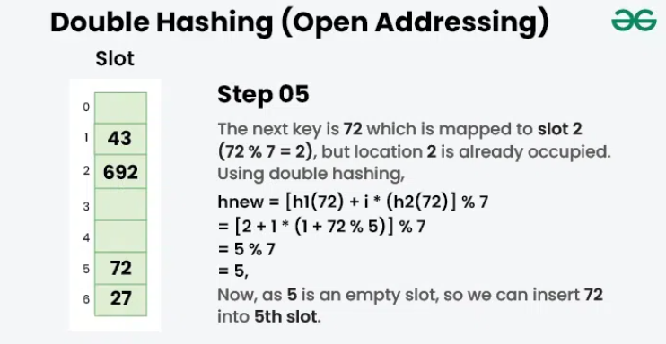

What is meant by Load Factor in Hashing?

The load factor of the hash table can be defined as the number of items the hash table contains divided by the size of the hash table. Load factor is the decisive parameter that is used when we want to rehash the previous hash function or want to add more elements to the existing hash table.
It helps us in determining the efficiency of the hash function i.e. it tells whether the hash function which we are using is distributing the keys uniformly or not in the hash table.

Load Factor = Total elements in hash table/ Size of hash table

What is Rehashing?

As the name suggests, rehashing means hashing again. Basically, when the load factor increases to more than its predefined value (the default value of the load factor is 0.75), the complexity increases. So to overcome this, the size of the array is increased (doubled) and all the values are hashed again and stored in the new double-sized array to maintain a low load factor and low complexity.
UNIT–IV– SCSA1206–CANDDATA STRUCTURES

